Online Shop Program Documentation

Group: SE2222

Team Members:

Aidos Tleukanov

Project Overview

Project Information

The "Online Shop Program" is a software application developed by the SE2222 group. This project is designed to demonstrate the implementation of six specific design patterns in a user-friendly command-line interface. The primary goal of this project is to showcase the practical application of design patterns in a real-world scenario. Each design pattern is used to address specific challenges and provide flexibility and extensibility to the software.

Project Objectives

Implement six different design patterns in a real-world online shop program.

Create a user-friendly command-line interface for interacting with the application.

Ensure a clean and maintainable codebase following the SOLID, DRY, and KISS principles.

Provide a comprehensive README file with UML diagrams to explain the design patterns used.

Main Body

Implemented Design Patterns

Singleton Pattern

Explanation: We utilized the Singleton pattern in the Cart class to ensure there's only one instance of the shopping cart throughout the application. This pattern helps us manage a single cart for each user session.

Screenshot 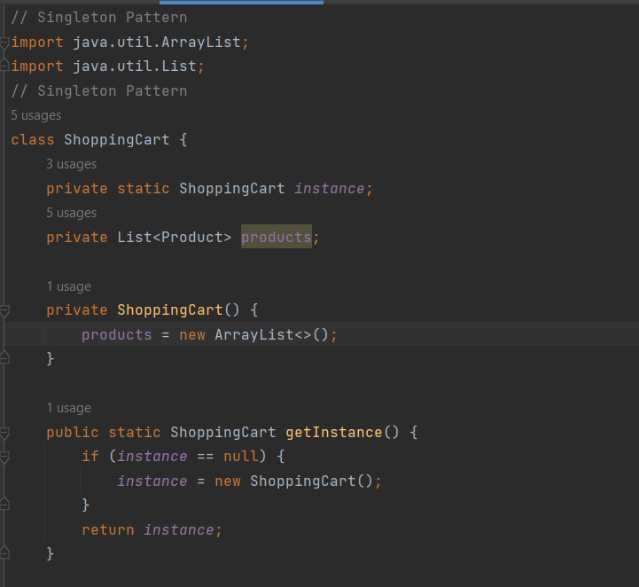

Strategy Pattern

Explanation: The Strategy pattern is employed for implementing different payment strategies such as credit card, PayPal, and cryptocurrency payments. This allows users to dynamically select their preferred payment method.

Screenshot

Decorator Pattern

Explanation: We applied the Decorator pattern to the Product class to add optional features to products dynamically. For example, users can add gift wrapping to their selected products, enhancing their shopping experience.

Adapter Pattern

Explanation: The Adapter pattern is used to integrate a third-party shipping service into the system, ensuring it works seamlessly with our order processing. This pattern facilitates the integration of external services.

Observer Pattern

Explanation: We implemented the Observer pattern to notify users about changes in the status of their orders. Users can register as observers and receive notifications when their order status changes.

Factory Pattern

Explanation: The Factory pattern is employed in the ProductFactory to create various types of products. For instance, we have a factory for creating basic products. This simplifies the process of product creation.

Conclusion

Key Points

The "Online Shop Program" successfully demonstrates the practical application of six design patterns (Singleton, Strategy, Decorator, Adapter, Observer, and Factory) to address specific challenges and enhance the flexibility and extensibility of the application.

Project Outcomes

The development of this project has provided valuable experience in applying design patterns to real-world software development, resulting in a more maintainable and adaptable codebase.

Challenges Faced

Throughout the project, we encountered challenges, such as [mention specific challenges], but we overcame them through collaboration and research.

Future Improvements

To enhance our project, we plan to [describe potential improvements or additional features that can be implemented]. We will continue refining the user interface and expanding the functionality based on user feedback.

This documentation provides an overview of the "Online Shop Program," outlining the objectives, design patterns used, and their implementations. The accompanying UML diagram illustrates the structure of the design patterns. The project demonstrates a practical application of design patterns in software development and provides a foundation for future enhancements.